|  |
| --- |
|  |
| ABC Healthcare Mockup Screen |
| Healthcare Patient Registration |
|  |
| **Raphael Amanpene** |
| **9/24/2024** |

This document is a Mockup Screen of ABC Healthcare Patient Registration

Page 1

* + 1. User Interface

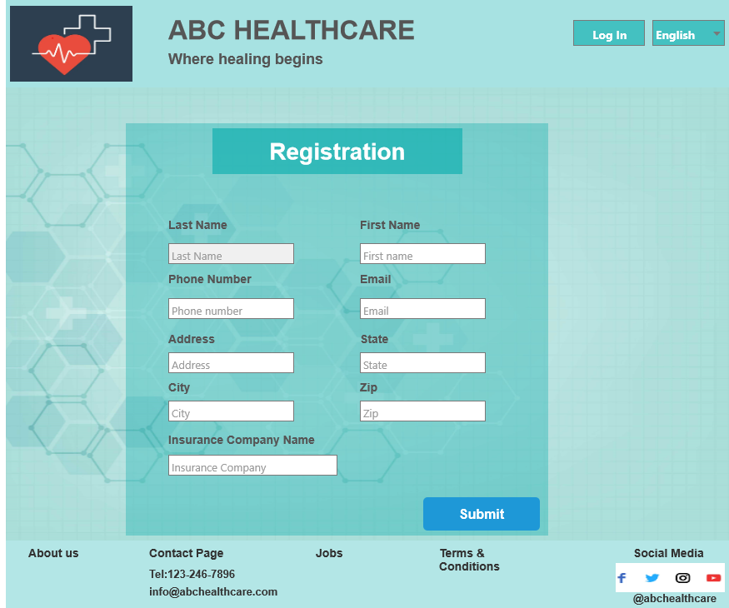

Page 2

***Meeting Minutes***

**Host:**                Nandu Vaid

**Attendees:**Raphael Amanpene

**Date:**9/22/2024

**Time:**9:15 pm

**Topic:**           User Requirements for ABC Healthcare Registration Page

1. Static Page - ABC Registration Page must comprise of 3 sections namely,

1. The Header
2. The Details Section
3. The Footer Section

2. The Header section must include the following fields.

1. The Logo
2. The Name of Business
3. The Slogan
4. Login
5. Language (English) as Default

3. The Details section must include the following 7 fields namely,

1. Last Name
2. First Name
3. Phone number
4. Email id
5. Address
6. City
7. State
8. Zip
9. Insurance Company Name

4. Bottom of the page must include the following information

1. About us
2. Contact Page (Phone, Email)
3. Job
4. Terms & Conditions
5. Social Media